SPH3U **Physics Skills Diagnostic**  Name:__________

**Rearranging Formulas:**

1. Rearrange each formula to solve for the indicated quantity.

a) $E=VIT$; Solve for V b) $p=\frac{F}{A}$; Solve for A c) *v= 303 + 0.6T ;* Solve for T

2. Given the equation: $D= \frac{M}{V}$, find V if D= 2.4 g/cm3 and M = 12.0 g. Include units in your answer!

3. Given the equation: $A=πr^{2}$, find r if A= 25.0 cm2 . Include units in your answer!

**Graphing and Calculating Slope**

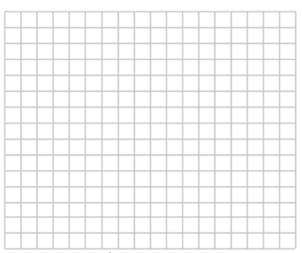4. A student measures mass and volume of several different samples of an unknown metal. The student’s measurements are shown in the table below.

|  |  |
| --- | --- |
| Volume (cm3) | Mass (g) |
| 0.0 | 0.0 |
| 3.0 | 28.0 |
| 6.5 | 45.0 |
| 10.5 | 80.0 |
| 15.2 | 125.0 |
| 16.0 | 130.0 |

a) Plot a graph of mass versus volume.

(*Volume goes on the x or horizontal axis.*

*Mass goes on the y or vertical axis.)*

b) Draw a best fit line through your data.

c) Find the slope of the best fit line to determine the average density of the samples. What are the units of density?